|  |  |
| --- | --- |
| Team ID | PNT2022TMID19409 |
| Project Name | Smart Waste Management System For Metropolitan Cities |

Project Development - Delivery Of Sprint-3

# Methodology:

As the waste is delivered, the conveyor belt motor activates and the conveyor belt starts to move. The microcontroller, along with several of the motors and controls, have all been turned on. It is more important to be kind-hearted about how well each of us, as individuals, manages our affluence and environment in light of the significantly expanding human population and the current COVID pandemic. Given the information, it is clear that a pristine atmosphere calls for a genuine clinical waste evacuation. The modern waste segregator is a competent and cost-effective waste combining structure that uses a minimal amount of human intervention and poses no risk to human life. The system is substantially more precise, financially astute, and easier to install and utilise locally when a car line is used. It will save time to separate these catastrophes at the local level in a similar way. The proposed construction satisfies the need for dependable monitoring of the rubbish inside the containers. It aids in getting rid of the trash before it overflows the canisters. Therefore, common observing and advising play a large role in the board's waste. This results in a clean city where people can live better.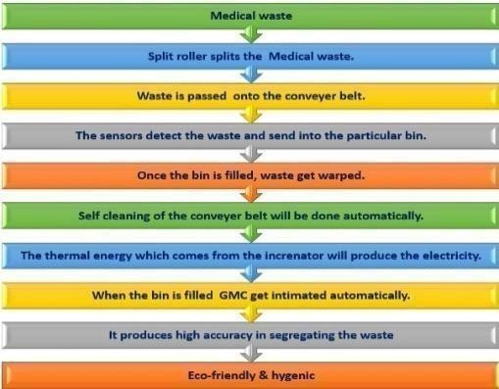

# Optimal Path Planning Algorithm for Waste Collection:

Step 1: Configure the sensors and the microcontroller.

Step 2:Turn on the ESP8266 and initialise the SIM

Step 3: The mobile device uses an IP address to connect to the network when Wi-Fi is enabled.

Step 4: An SMS message is delivered when the bins' height and weight go over the margin.

Step 5: You may check the status of the containers by using the IP Address listed on the HTML tab.